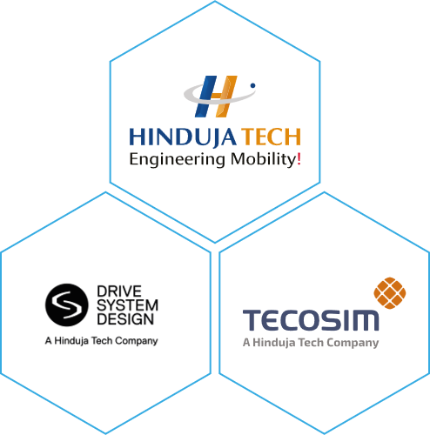  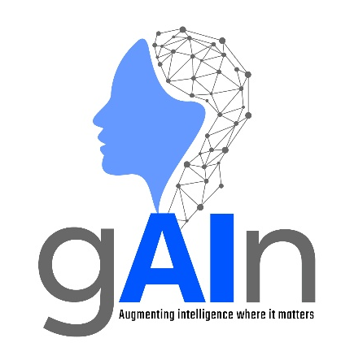 | AI Centre of excellence  AGENTIC AI OVerview – Entry Level  Version 1.0

© Copyright: All contents in this document belong to Hinduja Tech Limited. None of the contents from this document shall be reproduced, copied, or used outside Hinduja Tech without prior written approval of the Hinduja Tech AI Governance Board.

What is Agentic AI?
Agentic AI refers to AI systems that can autonomously pursue goals, make decisions, and take actions with limited human intervention.
Unlike traditional AI or Generative AI, which typically responds to a single prompt, Agentic AI can plan, evaluate options, gather information, execute tasks, monitor progress, and adapt its behaviour to achieve an objective.
Additionally, Agentic AI systems generally combine an AI model with access to tools such as web search, databases, business applications, API (Application Programming Interface), or software systems. The AI model decides which tools to use and in what sequence to achieve a goal.
Agentic AI vs Generative AI
In many cases, Large Language Models (LLMs) provide the reasoning capability behind an agent, while other tools and systems enable actions to be carried out. It can be helpful to know the differences between Generative AI systems and Agentic AI systems.
Generative AI | Agentic AI
Responds to prompts. | Pursues goals autonomously.
Generates content such as text, images, or code. | Can generate content and take actions.
Usually performs a single task. | Can manage multi-step workflows.
Requires user direction at each stage. | Determines next steps within predefined rules and permissions.
Reactive. | Proactive.

As an example, to illustrate this difference, consider an engineer investigating an issue on a test rig. Interrogating Generative AI, you could ask a prompt such as:
"Summarise the key findings from this inverter efficiency test report."
The model would then analyse the information provided and generate a response.
In contrast, an Agentic AI, built to support engineering investigations, behaves autonomously. In this example case, it could retrieve test data from multiple sources and compare results against previous programmes. It could also identify anomalies and recommend potential root causes; review relevant requirements and specifications; produce summary reports; and assign follow-up actions to the appropriate engineers for review.
Advantages of Agentic AI
Advantage | Explanation
Continuous Operation | Agentic AI is goal-focused rather than task-focused, allowing it to work continuously towards an objective with minimal human intervention.
Higher Productivity | By executing multiple processes simultaneously, Agentic AI can complete complex workflows faster than traditional approaches. This reduces manual effort and allows people to focus on higher-value activities.
Faster Decision-Making | Agentic AI can analyse large volumes of information quickly, enabling faster and more informed decisions.
Cost Reduction | Automation of repetitive tasks can improve efficiency and may reduce operational costs.
Updated Perspectives | Agentic AI can continuously gather and evaluate new information, helping identify trends, risks, anomalies, and opportunities that might otherwise be overlooked.
Cross-System Operation | Agentic AI can work across multiple applications, databases, and data sources as part of a single workflow, enabling end-to-end process automation.

Typical Business Applications
Application | Example Application
Customer Support | Resolving common enquiries and triggering follow-up actions.
Research & Analysis | Gathering and summarising information from multiple sources.
Scheduling | Managing meetings, diaries, and reminders.
IT Operations | Monitoring systems and escalating issues.
Document Processing | Reviewing, categorising, and routing documents.
Procurement | Comparing suppliers and generating purchase requests.
Engineering & Testing | Reviewing analysis results and flagging anomalies.
Engineering Investigation | Reviewing test-cell data, identifying anomalies, comparing against previous programmes, generating summary reports, and recommending areas for engineer review.

Limitations and Risks
Agentic AI systems have significant capabilities and are powerful tools when used appropriately. However, they are constrained by limitations and can pose security, compliance, and operational risks if not governed appropriately.
Limitation / Risk | Explanation
Clear Goals and Governance Required | Agentic AI requires well-defined objectives, rules, and oversight to ensure it operates as intended.
Dependent on Data Quality | Poor, incomplete, or inaccurate data can lead to poor decisions and unreliable outcomes.
Human Oversight Still Needed | High-risk, sensitive, or business-critical decisions still require human review and approval.
Security and Access Control | Permissions and system access must be carefully managed to prevent unauthorised actions or data exposure.
Greater Complexity | Agentic AI systems are typically more complex to design, implement, monitor, and maintain than traditional AI chatbots.
Key Takeaway
Generative AI helps users create content and answer questions. Agentic AI goes further by pursuing goals, coordinating tasks, using tools, and taking actions within defined rules. Agents can boost productivity and automate complex workflows, but require strong oversight, security, and governance.

