   | AI Centre of excellence  aRTIFICIAL NEURAL NETWORKS OVERVIEW – ENTRY LEVEL  Version 1.0

© Copyright: All contents in this document belong to Hinduja Tech Limited. None of the contents from this document shall be reproduced, copied, or used outside Hinduja Tech without prior written approval of the Hinduja Tech AI Governance Board.

Artificial Neural Networks (ANNs)
What Are ANNs?
Artificial Neural Networks (ANNs) are a form of machine learning. Often called neural networks, ANNs are inspired by the structure of biological neural networks and consist of interconnected nodes. These nodes act as artificial neurons that receive inputs, process information, and generate outputs.
Deep learning is a type of machine learning that uses large neural networks with many layers. These networks power many recent advances in artificial intelligence.
Advantages
Advantage | Description
Learns Complex Patterns | Can identify relationships in data that are difficult for traditional programming to capture.
Highly Versatile | Applicable across healthcare, finance, marketing, engineering, climate science, and many other industries.
Improves with Data | Performance improves as more training data becomes available.
Automation and Efficiency | Can analyse large volumes of data faster than humans, reducing manual effort and speeding up decision-making.
Supports Innovation | Enables applications such as advanced image recognition, speech recognition, and modern generative AI systems.

How Do ANNs Learn?
ANNs learn through a repeated process of forward propagation and backpropagation.
Forward propagation is the process of producing an output from a given input. Information moves between layers of interconnected neurons or nodes that form the network. Each connection is assigned a numerical weight that determines its influence on the final result.
In contrast, backpropagation is the learning process. The network compares its output with the correct answer and calculates the error. The contribution of each connection to that error is estimated using backpropagation, and the weights are adjusted using an optimisation technique called gradient descent to reduce that error.
This process is repeated over and over again until the network's predictions have become sufficiently accurate. It is this ongoing cycle of prediction, error measurement, and adjustment that trains ANNs.
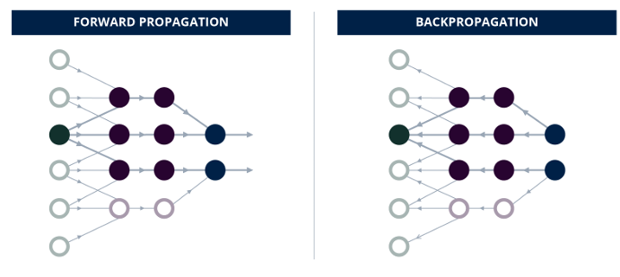Visual comparison of forward and backward propagation. Adapted from Kuwajima (2014).

Limitations
Limitation | Description
Data Intensive | Requires large volumes of high-quality training data to perform effectively.
High Computational Cost | Training complex neural networks can require significant computing power and expense.
Lack of Transparency | Due to the many layers of neurons, it can be hard to understand and explain why models produce certain outputs.
Potential Bias | Models can inherit biases present in their training data
Accuracy Challenges | Performance can deteriorate when faced with unusual, poor-quality, or unseen data.

Common Applications of ANNs
ANNs have wide-ranging applications.
In image recognition, they analyse visual features that can identify objects, patterns, and other characteristics within images. This enables technologies such as quality inspection systems and smartphone face authentication.
In speech recognition and natural language processing, ANNs enable virtual assistants such as Siri and Gemini to understand spoken language and generate responses.
In engineering and computer-aided engineering (CAE), ANNs can be trained using simulation and experimental data to create surrogate models that rapidly approximate structural, thermal, fluid-flow, and other performance characteristics. This enables engineers to evaluate design options more quickly and focus detailed simulation and testing on the most promising solutions

