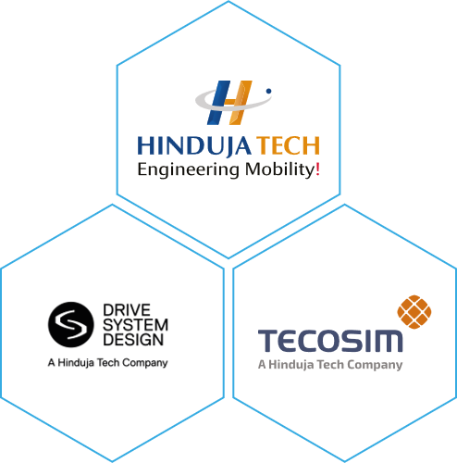  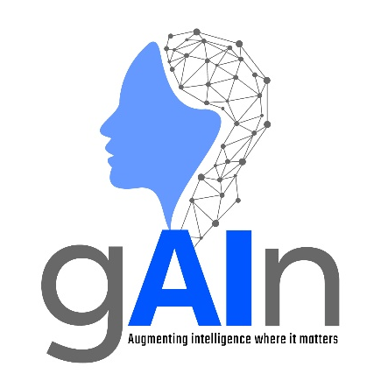 | AI Centre of excellence  Automation and ai overview – Entry Level  Version 1.0

© Copyright: All contents in this document belong to Hinduja Tech Limited. None of the contents from this document shall be reproduced, copied, or used outside Hinduja Tech without prior written approval of the Hinduja Tech AI Governance Board.

Automation and AI
What are Automation and AI?
Although often referred to synonymously, Automation and Artificial Intelligence (AI) are not the same thing.
Automation uses technology to perform predefined tasks or processes with minimal human intervention. It follows predefined rules and delivers consistent outcomes. For instance, a system that automatically emails a receipt following an online purchase.
Artificial Intelligence (AI) enables systems to recognise patterns and relationships within data and generate outputs such as predictions, recommendations, content, or decisions. This supports decision-making in situations that are more complex or variable. For instance, analysing customer behaviours to predict which products other customers are most likely to buy.
The Evolution of Automation and the Integration of AI
Automation has existed for centuries. From mechanical devices such as water wheels and factory machinery, automation has evolved into modern industrial and digital systems.
Today, organisations increasingly use Robotic Process Automation (RPA) to automate business processes such as:
- Data entry
- Form filling
- Transaction processing
- Report generation
- Customer service activities
Recent developments have sought to integrate AI into these automated processes. The introduction of AI enables automation to move beyond simple rule-based tasks to handling more complex situations.
In AI-assisted automation, AI may interpret information or recommend a decision, while the automation workflow applies rules, interacts with systems, and carries out the resulting actions.
Traditional Automation vs AI-Powered Automation
The table below summarises some of the key distinctions between traditional automation and AI-assisted automation.
Traditional Automation | AI-Assisted Automation
Follows predefined rules. | Uses models developed from data to support more variable situations.
Best for repetitive, predictable tasks. | Can support decision-making and handle greater complexity.
Produces predictable outputs for a given set of inputs and rules. | Can generate different outputs depending on the input and context.

Advantages of Automation
Advantage | Description
Increased Productivity | Reduces time spent on repetitive tasks.
Improved Efficiency | Streamlines workflows and business processes.
Reduced Costs | Lowers manual effort and operational overheads.
Greater Consistency | Performs tasks in a reliable and repeatable manner.
Improved Accuracy | Reduces human error in routine activities.
Scalability | Allows organisations to process larger volumes of work.

Examples of AI-Assisted Automation
Application | Example Use
Chatbots and Virtual Assistants | Answer customer queries, process requests and direct users to appropriate services.
Payroll Processing | Automation can calculate wages, manage overtime, process payments and support tax reporting. AI can assist by identifying unusual entries or potential errors for review.
Personalised Recommendations | Suggest products, services or content based on user behaviour and preferences.
Autonomous Vehicles | Combine automation and AI to interpret surroundings and make driving decisions.
Business Process Automation | Automatically classify information, extract relevant data and process large volumes of transactions and routine workflows.

Limitations and Risks
Limitation / Risk | Description
Data Quality Issues | AI systems can produce poor results when trained on inaccurate or biased data.
Limited Human Judgement | Systems may struggle with situations requiring context, empathy or ethical decisions.
Over-Reliance on Technology | Excessive dependence on automation may create operational risks if systems fail. Appropriate human oversight should be defined according to the risk, complexity and potential impact of the process.
Security Risks | Automated systems can be targets for cyber-attacks, and errors or unauthorised actions may be amplified when processes operate at speed and scale.
Privacy Concerns | Sensitive data may be exposed if systems are not properly managed and secured.
Implementation Costs | Initial deployment can require significant investment.

Key Takeaway
Automation and AI work best together. Automation efficiently handles predefined tasks, whilst AI interprets information and supports decisions. Combined, they enable organisations to automate more complex workflows while maintaining speed, consistency, and scalability.

