  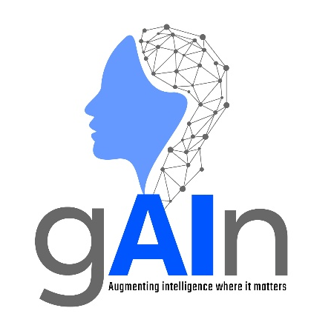 | AI Centre of excellence  Large Language Models OVERVIEW – Entry Level  Version 1.0

© Copyright: All contents in this document belong to Hinduja Tech Limited. None of the contents from this document shall be reproduced, copied, or used outside Hinduja Tech without prior written approval of the Hinduja Tech AI Governance Board.

Large Language Models
What are Large Language Models?
A Large Language Model (LLM) is a type of Artificial Intelligence (AI) designed to understand and generate human language. LLMs are trained on vast amounts of text and learn patterns, grammar, context, and relationships between words. This enables them to answer questions, summarise information, generate content, and hold conversations.
Commonly used LLM examples include Microsoft Copilot, ChatGPT, Claude, and Gemini.
Background
Although language AI research began many years ago, a major breakthrough occurred in 2017 with the introduction of the Transformer architecture, which became the foundation of most modern LLMs.
Transformers allowed AI systems to process relationships between many words simultaneously. This made training models much faster and more effective than previous approaches. This led to the development of modern LLMs that are now widely used in business and everyday life.
How LLMs are Trained
Training
Training LLMs is a process that is useful to know to help understand how LLMs work. This can be summarised in a few key steps:
- Pre-training: The model learns the fundamentals of language by analysing large amounts of text from books, websites, and articles. By predicting missing or next words in prose, the model learns grammar, meanings and patterns.
- Transfer Learning: Once the model has learned basic language skills, it can draw on this knowledge when tackling new tasks. By reusing information in this way, the amount of additional training and data required is reduced.
- Fine-tuning: Following this, the model can be adapted for specific tasks, such as document classification. This is achieved by providing the model with smaller sets of labelled examples to improve performance in a particular area.
- Reinforcement Learning with Human Feedback: In this final stage, human reviewers evaluate and rank the model's responses, helping it learn which answers are most appropriate. This aligns the model more closely with human expectations.
Example
During pre-training, the model may see:
"The capital of India is _____"
By repeatedly predicting missing words across billions of examples, the model learns language patterns, factual relationships, and behaviours that can resemble reasoning.
How LLMs are Improved During Use
Once trained, LLMs can be enhanced through a range of techniques during use. These techniques help improve the quality and relevance of responses without typically altering the model's core parameters. Summarised in the table below are a few methods of achieving this.
Technique | Description
Zero-Shot Learning | Performs a task using only instructions and no examples.
Few-Shot Learning | Uses a small number of examples provided in a prompt.
In-Context Learning | Uses information supplied in the current conversation or prompt to perform a task without additional training.
Retrieval-Augmented Generation (RAG) | Retrieves information from documents or databases that it was not trained on before generating a response. This improves accuracy and access to current information.
Prompt Engineering | Carefully designing prompts and instructions to improve output quality and relevance.
For more information on RAG and Prompt Engineering, consult the other crib sheets available on these topics.

Advantages of LLMs
Advantage | Example
Natural language interaction | Users can communicate using everyday language rather than technical commands.
Increases productivity | Assists with drafting emails, reports, meeting notes and presentations.
Rapid information summarisation | Condenses large documents into concise summaries.
Supports knowledge work | Helps analyse information, generate ideas and answer questions.
Versatile | Can perform many different tasks using a single system.
Accessible to non-experts | Enables users without technical expertise to benefit from AI capabilities.

Limitations and Risks
LLMs, whilst powerful tools, are limited. Any outputs generated by LLMs should always be reviewed by a competent human before being relied upon for important decisions.
Limitation/Risk | Description
Hallucinations | LLMs can generate convincing but incorrect information. This is commonly referred to as ‘hallucinating’.
Training data bias | Models reproduce inaccuracies or biases present in training data.
No true understanding | LLMs primarily recognise patterns in language and do not possess human-like understanding, awareness, or consciousness.
Dependent on prompt quality | Better instructions generally produce better outputs.
Risk of over-reliance | Users may accept AI outputs without sufficient checking.
Privacy and security concerns | Sensitive information should only be entered into approved systems in accordance with company policies.
May contain outdated information | Knowledge may be limited to training data unless connected to external sources through RAG.

Common Applications of LLMs
Application | Example Use
Writing and Content Creation | Producing reports, emails, presentations and summaries.
Code Generation and Debugging | Writing, explaining and troubleshooting software code.
Legal and Contract Analysis | Reviewing contracts and identifying important clauses.
Cyber Security | Analysing security logs and summarising alerts.
Financial Analysis | Reviewing reports, analysing trends and assisting with financial reporting.
Customer Support | Powering chatbots and virtual assistants.
Knowledge Management | Searching, summarising and answering questions about organisational information.

Key Takeaway
Large Language Models enable users to interact with AI using natural language to generate, analyse and summarise information. However, their outputs should always be reviewed by a competent human due to limitations such as hallucinations, bias and outdated knowledge.

