  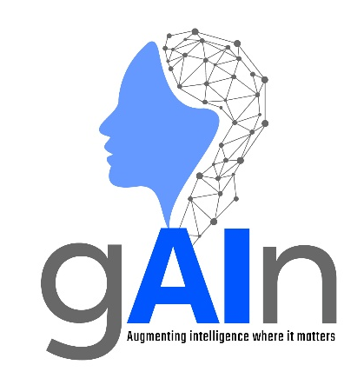 | AI Centre of excellence  MACHINE LEARNING OVERVIEW – ENTRY LEVEL  Version 1.0

© Copyright: All contents in this document belong to Hinduja Tech Limited. None of the contents from this document shall be reproduced, copied, or used outside Hinduja Tech without prior written approval of the Hinduja Tech AI Governance Board.

Machine Learning
What is Machine Learning?
Machine Learning (ML) is a field of Artificial Intelligence (AI) that enables systems to identify patterns in data and use those patterns to make predictions or decisions. ML systems do not need to be explicitly programmed for every scenario. Rather than following fixed rules, ML systems identify patterns in data and improve their performance as they are exposed to additional data, feedback, or training.
Despite the name, ML is not fully automated. Humans play a significant role in selecting data, choosing algorithms, defining features, evaluating results, and refining models.
How Machine Learning Works
Machine learning works by converting information into numerical data that algorithms can process. Relevant characteristics of the data, known as features, are selected and refined so that only the most meaningful information is used.
Many machine learning models are built around three key concepts:
- Decision Process – Makes a prediction or classification.
- Error Function – Measures how accurate the prediction was.
- Optimisation Process – Adjusts the model to improve future predictions.
Through repeated cycles of prediction, feedback and adjustment, the model gradually improves its accuracy.
Example
A movie recommendation system may incorporate machine learning.
The system learns from:
- Films users have watched
- Ratings given to films
- Preferred genres, actors, or directors
- Viewing habits
If recommendations are successful, the model reinforces the factors that led to the recommendation. If not, it adjusts them to reduce future errors.

Main Types of Machine Learning
There are several different types of machine learning. Broadly, they fall into three main categories: Supervised Learning, Unsupervised Learning and Reinforcement Learning. These are summarised in the table below.
Approach | Definition | Common Application
Unsupervised Learning | Learns patterns and relationships from unlabelled data without being told the correct answers. | Detecting anomalies and unusual behaviour when little or no labelled data exists.
Supervised Learning | Learns from labelled historical data where the correct outcome is known and uses this knowledge to classify or predict new cases. | Automatically classifying results and identifying known issues when sufficient labelled data is available.
Reinforcement Learning | Learns through trial and error, receiving rewards for good decisions and penalties for poor ones. | Optimising decision-making where actions can be evaluated through rewards or penalties, such as robotics, game-playing systems and autonomous control.

Machine Learning vs Large Language Models (LLMs)
Machine Learning is a broad technology covering many different types of models and applications. All LLMs are machine learning models, but not all machine learning models are LLMs.
LLMs, such as ChatGPT and Copilot, are a specialised category of machine learning focused on understanding and generating human language. LLMs can answer questions, summarise documents and generate text. A purely machine learning model could predict battery health, identify unusual vehicle behaviour, or estimate remaining useful life from operational data.

Advantages of Machine Learning
Advantage | Example Application
Automates repetitive tasks | Fraud detection systems can automatically identify suspicious transactions.
Identifies patterns humans may miss | Optical Character Recognition (OCR) systems can recognise patterns in technical documents and images.
Improves with additional training data | Movie recommendation systems can become more accurate when periodically retrained using user feedback and additional data.
Can handle very large datasets | Marketing systems analyse large volumes of customer data to predict likely responses to campaigns.
Enables innovative solutions | Self-driving vehicles, voice assistants and multimodal AI systems are powered by ML techniques.
Can discover hidden insights | Finds relationships and trends that may not be obvious to human analysts.

Limitations and Risks of Machine Learning
Limitation/Risk | Description
Requires significant human input | Data selection, labelling, model design and refinement are all heavily dependent on experts.
Dependent on data quality | Poor or incomplete data can produce inaccurate predictions.
Algorithmic bias | Biased training data can lead to biased or unfair outcomes.
Lack of transparency | Due to their complexity, it can be difficult to understand and explain why some models produce certain outputs.
Computational cost | Training and operating models can require significant computing resources.
Security and privacy concerns | Models often require access to large datasets, some of which may contain sensitive information.
Not suitable for every problem | Some problems are not suited to machine learning because sufficient data is unavailable or because rule-based approaches are more effective.
Reinforcement learning limitations | Learning through failure is unsuitable where mistakes could cause harm or significant cost to businesses.

